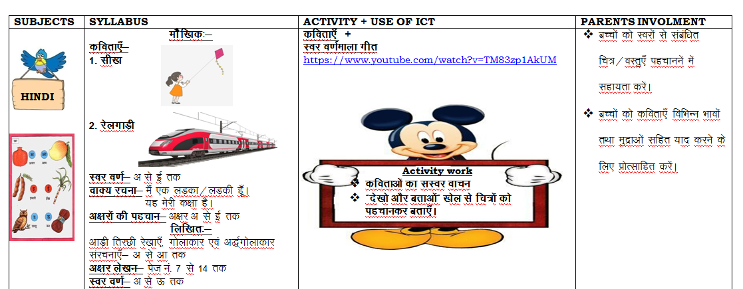
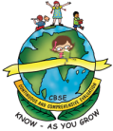
GREENWOOD PUBLIC SCHOOL
ADITYAPURAM, GWALIOR
SESSION 2022-23 : SYLLABUS FOR THE MONTH OF AUGUST : CLASS-NURSERY
SUBJECTS | SYLLABUS |  | ACTIVITY + USE OF ICT |  |  | PARENTS INVOLMENT
ENGLISH  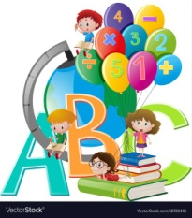  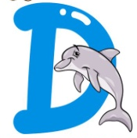  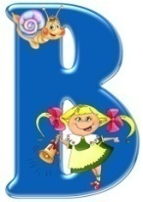  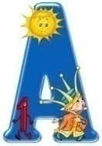 | ORAL:  Rhymes-  1. Two Little Hands  2. Mummy and Daddy  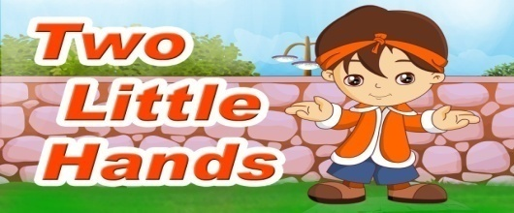  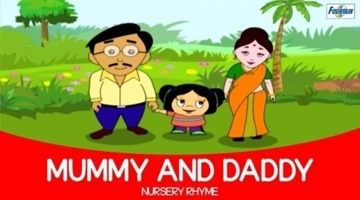  Sentence Structure- This is my school.  Vocabulary Building-  School, home, room, garden, colours  Recognition- A-F  WRITTEN:  Alphabets- E,F  Workbook- Page no. 11 to 15  Revision- A-D, Previous Rhymes of March, April and July |  | Rhymes +  Phonics Sound  https://www.youtube.com/watch?v=hq3yfQnllfQ  Alphabet Song  https://www.youtube.com/watch?v=zAlX1V3lK5s  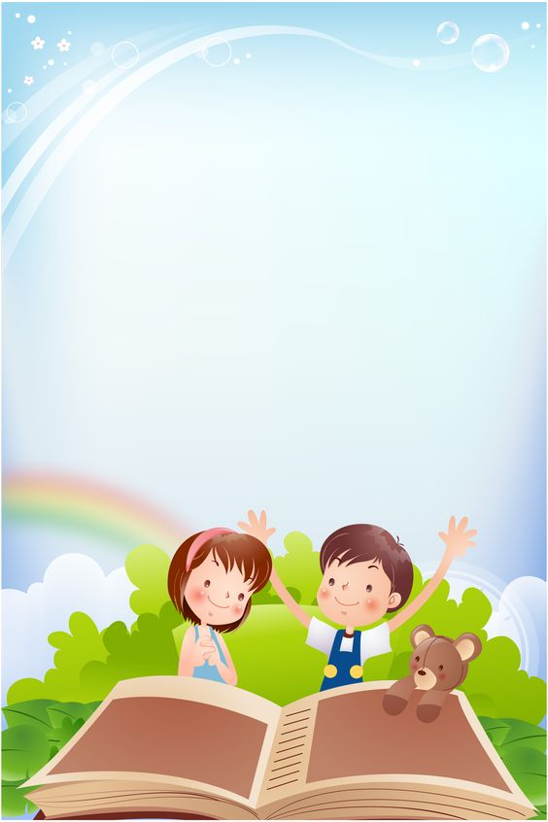  Activity Work  - ‘Look and Identify’ Game will be played for the recapitulation of the letters and their related objects. Learners will be asked to look and identify the objects as shown by the teacher.  - ‘Show and Tell’ Picture Reading Activity |  |  | - Help your child in learning rhymes.  - Help your child in doing his/her homework.  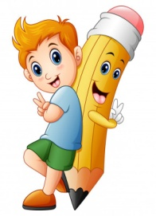
SUBJECTS | SYLLABUS |  | ACTIVITY + USE OF ICT |  |  | PARENTS INVOLMENT
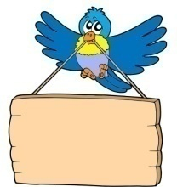  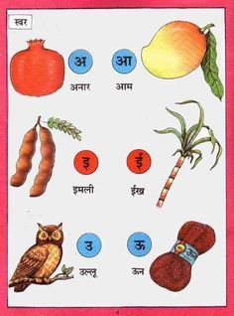  HINDI | ekSSf[kd%&  dfork,¡&  1- fcYyh ekSlh  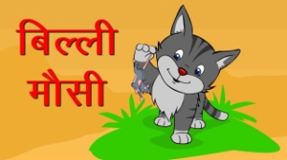  2- frryh  Loj o.kZ& v ls Å rd  okD; jpuk& ;g esjh d{kk gSA  ;g esjk fo|ky; gSA  v{kjksa dh igpku& v{kj v ls Å rd  fyf[kr%&  lajpuk,¡& v ls Å rd  v{kj ys[ku& ist ua- 9 ls 14 rd  iqu% vH;kl& lajpuk & v ls Å rd  dfork,¡& ekpZ] viszy o tqykbZ dh dfork,sa |  | dfork,¡ +  Loj o.kZekyk xhr  https://www.youtube.com/watch?v=TM83zp1AkUM  Activity work  - dforkvksa dk lLoj okpu  - Þns[kks vkSj crkvksaÞ [ksy ls fp=ksa dks igpkudj crk,¡A |  |  | - cPpksa dks Lojksa ls lacaf/kr fp=@oLrq,¡ igpkuusa esa lgk;rk djsaA  - cPpksa dks dfork,¡ fofHkUu Hkkoksa rFkk eqnzkvksa lfgr ;kn djus ds fy, çksRlkfgr djsaA
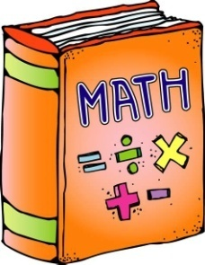 | 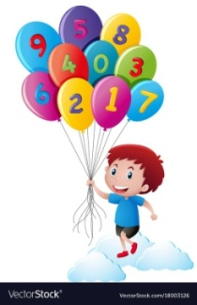  ORAL:  1. Counting from 1-20  2. Concepts- Big × Small, Long × Short, Thin × Fat, Black × White,  Sit × Stand, Up × Down  WRITTEN:  Numbers– 1 to 7, Match the numbers, Circle the numbers  Activity book- Page no. 10 to 15  Revision- Written-Numbers 1-5, Oral-Counting 1-10 |  | Counting Song  https://www.youtube.com/watch?v=JT0MmZcJ2Vw  Activity Work  - ‘Look and Identify’ Game related to “Big × Small, Long × Short, Thin × Fat, Black × White” objects, etc.  - Learners will be asked to count the objects asked by the educator. |  |  | - Motivate your child in counting objects  - Help your child in learning counting.  - Help your child in doing his/her homework.
SUBJECTS |  | SYLLABUS |  | ACTIVITY + USE OF ICT | PARENTS INVOLMENT
ART & CRAFT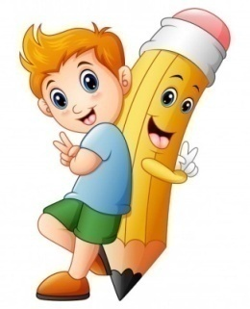 |  | Page no. 6,7,8  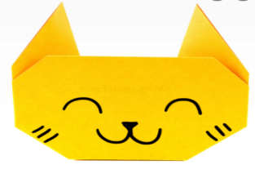  Craft- Origami Cat |  | Introduction to Shapes through “Shapes song”  https://www.youtube.com/watch?v=QBD7CB-rroo  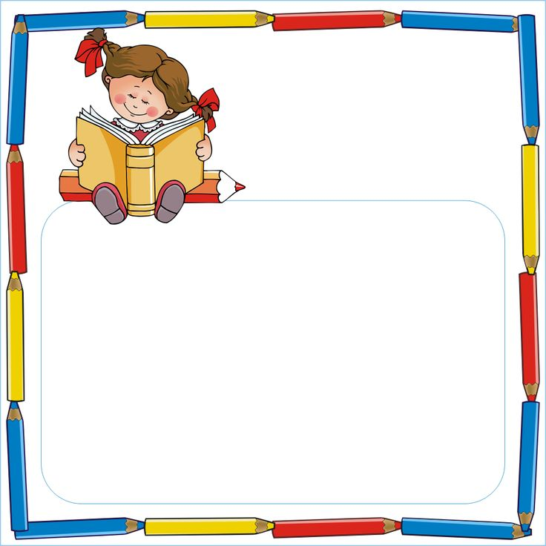  Activity Work  - ‘Look and Identify’ Shapes Game  - ‘Cut and Paste’ 4 shapes. | - Help your child to identify the shapes of daily life objects.
GENERAL KNOWLEDGE |  | Vegetables Name- Potato, Cauliflower, Brinjal, Onion, Tomato  Revision- Fruits Name, Colours Names |  | Colours name  https://youtube.com/watch?v=IEF8_q5yDYc&feature=share  Fruits name  https://youtube.com/watch?v=FSfoOQ_-dfw&feature=share  Activity Work  - Cut and Paste 5 fruits. | - Help your child to identify the body parts.  - Help your child to identify the family members.
VALUE EDUCATION |  | I love my school. I love my parents. |  | Moral Story  https://www.youtube.com/watch?v=MEVyl3jq_3c | - Make your child learn the names of family members.
PHYSICAL EDUCATION |  | Fun Games- Running, Jumping, Hopping, Skipping |  | DO EXERCISE THROUGH THIS LINK  https://www.youtube.com/watch?v=JoF_d5sgGgc | - Take your child to a park and play some games.
DANCE |  | 1. Patriotic Song  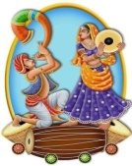  Nanha Munna Rahi Hu.. |  | Nanha Munna Rahi Hoon  https://www.youtube.com/watch?v=PKYjUOwAk38 | - Motivate your child to participate in school activities.
MUSIC |  | 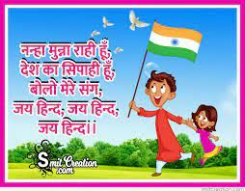  Rakhi Song and Patriotic Song |  | Nanha Munna Rahi Hoon  https://www.youtube.com/watch?v=PKYjUOwAk38 | - Help your child to learn the songs.
MOTOR SKILL DEVELOPMENT |  | 1. How to do Namaste  2. How to walk in a straight line  3. How to sit gracefully on the chair  4. How to use the washroom and wash hands |  | REFER THIS LINK  https://www.youtube.com/watch?v=wh6gt3IkRKk | - Help your child in practicing these skills at home.
LANGUAGE DEVELOPMENT |  | Can you help me? I am looking for.. , I love to play… |  | MY SCHOOL- https://www.facebook.com/watch/?v=25316 31197059981 | - Help your child to learn the name of school.

SUBJECTS | SYLLABUS | ACTIVITY + USE OF ICT | PARENTS INVOLMENT
CONVERSATION | ENGLISH CONVERSATION  1. What is your name?  Ans. My name is .  2. How are you?  Ans. I am fine, thank you.  3. How old are you?  Ans. I am 3 years old. | HINDI CONVERSATION  1- vkidk D;k uke gS\  m& esjk uke gSA  2- vki fdrus o’kZ ds gSa\  m& eSa rhu o’kZ dk gw¡A  3- vki dSls gS\  m& eSa vPNk@vPNh gw¡A  4- vki fdl d{kk esa i<+rs gSa\  m& eSa ulZjh esa i<+rk gw¡@i<+rh gw¡A | - Help your child in learning conversation questions.
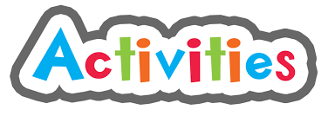 | 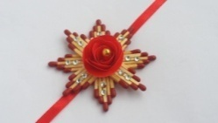  August-  Rakhi Making Activity (Rakshabandhan Celebration) (05/08/2022),  Fancy Dress Competition (Janmashtami Celebration) (12/08/2022),  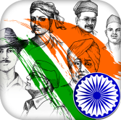  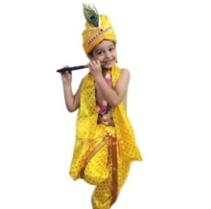  Independence Day Celebration (15/08/2022)

GREENWOOD PUBLIC SCHOOL
ADITYAPURAM, GWALIOR
SESSION 2022-23 : SYLLABUS FOR THE MONTH OF AUGUST : CLASS-LKG
SUBJECTS | SYLLABUS | ACTIVITY + USE OF ICT | PARENTS INVOLMENT
ENGLISH | ORAL:  Rhymes-  1. Baa-Baa Black Sheep  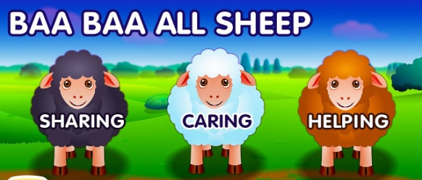  And Revision of previous rhymes.  Reading- English Pre Primer Page no. 3-18  Vocabulary Building- Book, Notebook, Pencil, Lunch Box, Pencil, Eraser, Crayons  WRITTEN:  Small Cursive letters (a-i),  What comes after, Write the first letter of the picture, Fill ups | Rhymes +  Phonics Sound  https://www.youtube.com/watch?v=hq3yfQnllfQ  Alphabet Song  https://www.youtube.com/watch?v=zAlX1V3lK5s  Vowels Song  https://www.youtube.com/watch?v=RUSCz41aDug  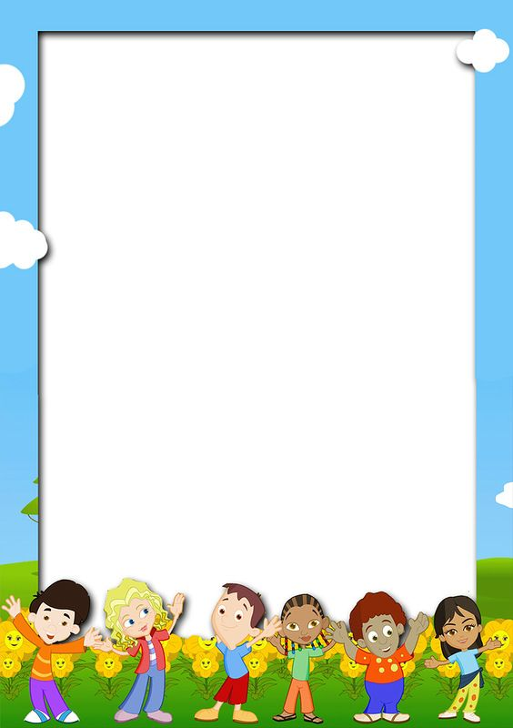  Activity Work  - ‘Look and Identify’ Game will be played for the recapitulation of the letters and their related objects. Learners will be asked to look and identify the objects as shown by the teacher.  - ‘Show and Tell’ Picture Reading Activity | - Help your child in learning rhymes.  - Help your child in doing his/her homework.  - Motivate your child to use the vocabulary words in daily life.  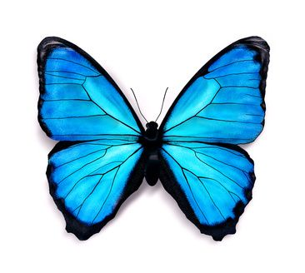

SUBJECTS | SYLLABUS | ACTIVITY + USE OF ICT | PARENTS INVOLMENT
HINDI | ORAL:  dfork,¡&  1- eEeh&ikik 2- xk;  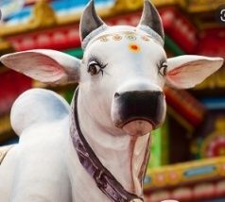  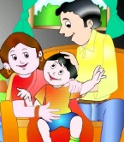  iBu ikBu& 'kCnekyk ist ua 3&10 rd  WRITTEN:  O;atu o.kZ & r ls u rd vkSj d ls .k rd dk iqu% vH;kl  Loj o.kZ& v ls v% rd dk iqu% vH;kl  fp= ns[kdj çFke o.kZ fyf[k,] fjDr LFkkuksa ij lgh Øekuqlkj o.kZ fyf[k,] tksM+h feykb, | dfork,¡&  esjk ?kj  https://www.youtube.com/watch?v=JeIdN0APfVY  o.kZekyk  https://www.youtube.com/watch?v=GBWGNvHsiFs  Activity Work  - dforkvksa dks lLoj okpu  - ns[kks vkSj crkvksaÞ [ksy ls fp=ksa dks igpkudj crk,¡A  - ^ns[kksa vkSj crkvks* [ksy ds tfj, o.kksaZ dks igpkub, ,oa crkb,sA | - cPpksa dks O;atuksa ls lacaf/kr fp=@oLrq,¡ igpkuusa esa lgk;rk djsaA  - cPpksa dks dfork,¡ fofHkUu Hkkoksa rFkk eqnzkvksa lfgr ;kn djus ds fy, çksRlkfgr djsaA
 | 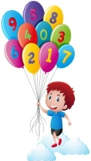  ORAL:  Forward Counting- 1 to 100,  Table of 2,  Number Names – 1-5  Comparison-One and Many,  Big and Small  WRITTEN:  Revision of numbers from 1 to 100,  Number Names 1-5, Fill in the missing numbers, Table of 2 | Counting-  https://www.youtube.com/watch?v=B5iAW-jnkPw  Table of 2-  https://www.youtube.com/watch?v=VKJ9cCQgPdc  Opposite Words  https://www.youtube.com/watch?v=HGeuA4iJ8vI  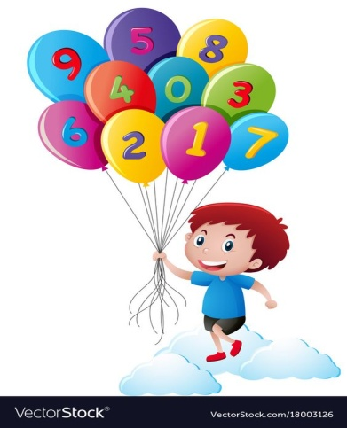 | - Help your child in learning counting.  - Help your child in doing his/her homework.
SUBJECTS | SYLLABUS | ACTIVITY + USE OF ICT | PARENTS INVOLMENT
ART &  CRAFT  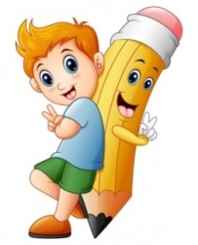 | Magic Sticks of Angel, Hut and Circle (Page no. 8,9 and 10) | Introduction to Shapes through “Shapes song”  https://www.youtube.com/watch?v=QBD7CB-rroo  Activity Work  - ‘Look and Identify’ Shapes Game  - ‘Cut and Paste’ Game of different objects. | - Help your child to identify the shapes of daily life objects.
GENERAL KNOWLEDGE | 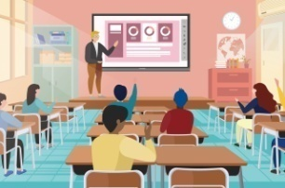  Pet Animals and The classroom  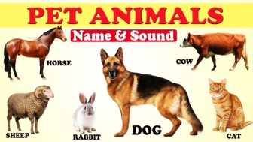 | Activity Work  - ‘Cut and Paste’ Game through the pictures of  Pet Animals. | - Help your child to identify the Pet Animals.  - Teach your child following good habits:  - Wish Good Morning  - Thank You  - Good Bye  - Wear your mask  - Use sanitizer
VALUE EDUCATION | Help your friends | Moral Story  https://youtu.be/5jJGdvajjjk
PHYSICAL EDUCATION | Fun Games- Running, Jumping, Hopping, Skipping &  Catching and Throwing | DO EXERCISE THROUGH THIS LINK  https://www.youtube.com/watch?v=JoF_d5sgGgc | - Take your child to a park and play some games.

SUBJECTS | SYLLABUS | ACTIVITY + USE OF ICT | PARENTS INVOLMENT
DANCE | 1. Patriotic Song  Nanha Munna Rahi Hu.. | Nanha Munna Rahi Hoon  https://www.youtube.com/watch?v=PKYjUOwAk38 | - Motivate your child to participate in school activities.
MUSIC | Rakhi Song and Patriotic Song | Nanha Munna Rahi Hoon  https://www.youtube.com/watch?v=PKYjUOwAk38 | - Help your child to learn the song.
LANGUAGE DEVELOPMENT | Describing words :  Right-Left, Happy-Sad, Hot-Cold, Dark-Bright | MY SCHOOL- https://www.facebook.com/watch/?v=25316 31197059981 | - Make your child to learn the name of school.
MOTOR SKILL DEVELOPMENT | 1. How to do Namaste?  2. How to walk in a straight line?  3. How to sit gracefully on the chair?  4. How to use the washroom and wash hands? | REFER THIS LINK  https://www.youtube.com/watch?v=wh6gt3IkRKk | - Help your child in practicing these skills at home.
CONVERSATION | English Conversation  Q-1 When do we celebrate Independence Day?  Ans- 15th August  Q-2 Name the National Flag of India.  Ans- Tricolour  Q-3 Why do we celebrate Rakhi?  Ans- Rakhi celebrates the bond between brothers and sisters.  Q-4 Why do we celebrate Janamashtami?  Ans- Lord Krishna’s birthday is celebrated as Janamashtami. | Hindi Conversation  1- Hkxoku d`’.k dk tUe dgk¡ gqvk Fkk\  m& Hkxoku d`’.k dk tUe eFkqjk esa gqvk FkkA  2- gekjs jk’Vª/ot esa fdrus jax gksrs gS\  m& gekjs jk’Vª/ot esa rhu jax gksrs gSA  3- gekjs ns'k esa Lora=rk fnol dc euk;k tkrk gS\  m& 15 vxLr  4- j{kkca/ku dc euk;k tkrk gS\  m& j{kkca/ku Jko.k ekl dh iwf.kZek dks euk;k tkrk gSA  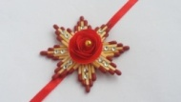 | - Help your child in learning conversation questions.
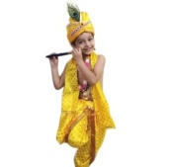
August-
Rakhi Making Activity (Rakshabandhan Celebration) (05/08/2022),
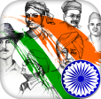
Fancy Dress Competition (Janmashtami Celebration) (12/08/2022),
Independence Day Celebration (15/08/2022)
GREENWOOD PUBLIC SCHOOL
ADITYAPURAM, GWALIOR
SESSION 2022-23 : SYLLABUS FOR THE MONTH OF AUGUST : CLASS-UKG
SUBJECTS | SYLLABUS | ACTIVITY + USE OF ICT | PARENTS INVOLMENT
ENGLISH | ORAL:  Rhymes-  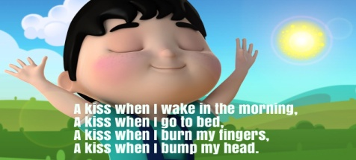  1. A Kiss When I Wake In The Morning  2. The Garden  Sentence Structure-  1. It is a pencil.  2. This is my classroom.  3. There are 5 books in my bag.  Reading- English Primer Page no. 16 to 23  Vocabulary Building- Rain, Umbrella, Gumboot, Raincoat  WRITTEN:  Workbook-  Sound of vowels i, o | Rhymes-  1. A Kiss When I Wake In The Morning  https://youtu.be/6uZNIS4O0rI  2. The Garden  https://youtu.be/r40UdqrSNIE  Sound of ‘a’  https://www.youtube.com/watch?v=Sno15qcDEr4  Sound of ‘e’  https://youtu.be/GMP1l6DezMs  Sound of ‘i’  https://youtu.be/ZNKI_iDuQDw  Sound of ‘o’  https://youtu.be/cYb_tv5aE9Y  Activity Work  - ‘Read and Tell’ Game will be played for the three letters words. Learners will be asked to read the words as shown by the teacher. | - Help your child in learning rhymes.  - Help your child in doing his/her homework.  - Motivate your child to read a, e, i, o sound words daily at home.
SUBJECTS | SYLLABUS | ACTIVITY + USE OF ICT | PARENTS INVOLMENT
HINDI | dfork,¡&  - ifj;ksa dh jkuh 2- vkt gekjh NqV~Vh gS  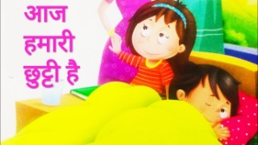  iBu ikBu& Loj ekyk i`"B Øekad& 8 ls 16  okD; jpuk& ;g ,d isafly gSA]  ;g esjh d{kk gSA ] esjs cLrs esa ik¡p fdrkcsa gSA  fyf[kr%&  vH;kl iqLrd&  ikB&7% bZ dh ek=k okys 'kCn]¼bZ& h½  ikB&8% m dh ek=k okys 'kCn]¼m& q ½  ikB&9% Å dh ek=k okys 'kCn]¼Å & w ½  lqys[k lq/kk& i`’B Øekad&9&15 | dfork,¡&  1- ifj;ksa dh jkuh  https://youtu.be/kxAVdDoZ9Tc  2- vkt gekjh NqV~Vh gS  https://youtu.be/7eACN-EMvhg  vk dh ek=k okys 'kCn  https://youtu.be/5502TLBgm0M  b dh ek=k okys 'kCn  https://youtu.be/PS3wOFKbtwo  bZ dh ek=k okys 'kCn  https://youtu.be/0LhB6MtdCu8  Activity Work  - dforkvksa dks lLoj okpu  - ns[kks vkSj crkvksaÞ [ksy ls fp=ksa dks igpkudj crk,¡A | - cPpksa dks ,d i`’B jkst vH;kl iqLrd i<+us esa lgk;rk djsaA  - cPpksa dks dfork fofHkUu Hkkoksa rFkk eqnzkvksa lfgr ;kn djkus ds fy, çksRlkfgr djsaA

SUBJECTS | SYLLABUS | ACTIVITY + USE OF ICT | PARENTS INVOLMENT
 | 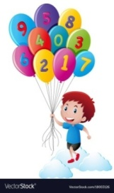  ORAL:  1. Counting from 1-200  2. Tables of 4 and 5  3. Number names from 31 to 50  WRITTEN:  Mathematics Primer-  Counting from 151 to 200  Number names from 21 to 30  Backward Counting- 30 to 1, After, Before, Between, Put the correct sign >,<,=, Table of 4 and 5 | Counting-  https://www.youtube.com/watch?v=B5iAW-jnkPw  Table of 4-  https://youtu.be/c85WRQLJH48  Table of 5-  https://youtu.be/rmQqvwlnvh8  Number Names  https://www.youtube.com/watch?v=LyvQ6pc7JSA  Activity Work  - ‘Look and Identify’ Number Game  - ‘Count and Tell’ Game. Learners will be asked to count the objects asked by the educator.  - ‘Dodging’ Game from the table of 4 and 5 | - Motivate your child in counting objects  - Help your child in learning counting.  - Help your child in doing his/her homework.
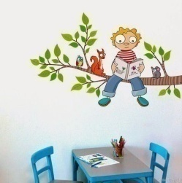  EVS | ORAL:  3. Stay Clean, Stay Healthy (Good Manners-(i) Wash your hands regularly  (ii) Have a bath daily  (iii) Trim your nails  (iv) Comb your hair  (v) Brush your teeth twice a day)  WRITTEN:  4. My family Members (Mother, Father, Brother, Sister)  5. Rooms in the house (Bedroom, Kitchen, Bathroom, Dining Room, Living Room) | 3. Stay Clean, Stay Healthy  https://youtu.be/gM-kBmgy1UM  4. This is my family  https://youtu.be/9glojunUOPU  Good Habits and Good Manners  https://www.youtube.com/watch?v=gwEgTQxZgw8 | - Help your child in doing his/her homework.  - Help your child to identify the body parts and ask their functions.  - Help your child to learn good habits.
ART & CRAFT | Page no. 7 to 10 (Uniform, Joker, Monkey, Helicopter)  Craft- Paper Flag, Moving Paper Toy | Craft-  Paper Flag  https://youtu.be/qdEnXm0feBU | - Help your child to identify the colours of daily life objects.
GENERAL KNOWLEDGE | Fruits names, Vegetables names &  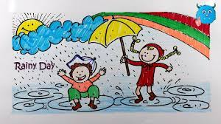  All about rainy season- Things we use in Rainy Season : Umbrella, Raincoat, Gumboot, Waterproof bag | All about rainy season  https://youtu.be/4xUBNX6qx7k  Activity Work  - Make a PAPER BOAT and float it in the  rain water also paste the photograph of it. | - Help your child identify the things in rainy season.
SUBJECTS | SYLLABUS | ACTIVITY + USE OF ICT | PARENTS INVOLMENT
VALUE EDUCATION | Speak Politely, Be honest | Moral Story  https://www.youtube.com/watch?v=ziXvFCKEGqM | - Teach your child good manners.
PHYSICAL EDUCATION | Fun Games- Running, Jumping, Hopping, Skipping | DO EXERCISE THROUGH THIS LINK  https://www.youtube.com/watch?v=JoF_d5sgGgc | - Take your child to a park and play some games.
DANCE | 1. Patriotic Song  Nanha Munna Rahi Hu.. | Nanha Munna Rahi Hoon  https://www.youtube.com/watch?v=PKYjUOwAk38 | - Motivate your child to participate in school activities.
MUSIC | Rakhi Song and Patriotic Song | Nanha Munna Rahi Hoon  https://www.youtube.com/watch?v=PKYjUOwAk38 | - Help your child to learn the prayers.
MOTOR SKILL DEVELOPMENT | 1. How to do Namaste?  2. How to walk in a straight line?  3. How to sit gracefully on the chair?  4. How to use the washroom and wash hands? | REFER THIS LINK  https://www.youtube.com/watch?v=wh6gt3IkRKk | - Help your child in practicing these skills at home.
LANGUAGE DEVELOPMENT | Can you help me?, I am looking for…, I love to play…
CONVERSATION | ENGLISH CONVERSATION  1. What is your grand father’s name?  Ans. My grandfather’s name is Mr. ………………..  2. What is your grand mother’s name?  Ans. My grandmother’s name is Mr. ………………..  3. What does your father do?  Ans. My father is a businessman/serviceman/teacher.  4. What does your mother do?  Ans. My mother is a businesswoman/ servicewoman/teacher/ housewife. | HINDI CONVERSATION  1- vki dgk¡ jgrs gks\  m& eSa Xokfy;j esa jgrk@jgrh gw¡A  2- vkidh d{kk v/;kfidk dk D;k uke gSa\  m& esjh d{kk v/;kfidk dk uke va'kw flag gSA  3- vkidh Ldwy ç/kkukpk;kZ dk D;k uke gSa\  m& esjh Ldwy ç/kkukpk;kZ dk uke oapuk ckMesjk gSA  4- vkidh Ldwy lapkfydk dk D;k uke gS\  m& esjh Ldwy lapkfydk dk uke Jherh fdju HknkSfj;k gSA | - Help your child in learning conversation questions.
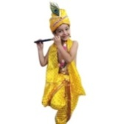
August-
Rakhi Making Activity (Rakshabandhan Celebration) (05/08/2022),
Fancy Dress Competition (Janmashtami Celebration) (12/08/2022),
Independence Day Celebration (15/08/2022)

